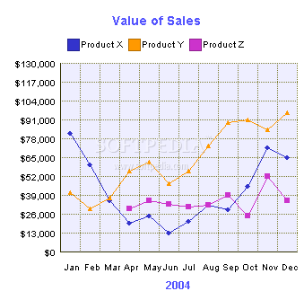

Match these words to places in the graphs which represent the meaning, for example jump

Fall

Plummet

Rise

Peak
Double

Decline

Improve

Drop
Rocket

Level off

Grow

Remain steady

Recover

Fluctuate

